Online Teaching

(Web application)

**Atif Shahzad**

**Hasnain Ali Taj**



**DEPARTMENT OF COMPUTER SCIENCE**

**COMSATS UNIVERSITY ISLAMABAD,**

**ATTOCK CAMPUS – PAKISTAN**

SESSION 2018-2021

Online Teaching

*Undertaken By:*

**Atif Shahzad**

CIIT/SP18-BCS-021/ATK

**Hasnain Ali Taj**

CIIT/sp18-BCS-005/ATK

*Supervised By:*

**Mr. Waqas Ahmad**

A DISSERTATION SUBMITTED AS A PARTIAL FULFILLMENT OF THE REQUIREMENTS FOR THE DEGREE OF BACHELOR OF SCIENCE IN

COMPUTER SCIENCE

**DEPARTMENT OF COMPUTER SCIENCE**

**COMSATS UNIVERSITY ISLAMABAD,**

**ATTOCK CAMPUS – PAKISTAN**

SESSION 2018-2021

**UNDERTAKEN**

We certify that this is my/our own work. The work has not, in whole or in part, been presented elsewhere for assessment. Where material has been used from other sources it has been properly acknowledged. If this statement is untrue, we acknowledge that we will have committed an assessment offence and shall be liable to punishable action under the plagiarism rules of HEC.

______________ _______________

Atif Shahzad Hasnain Ali tag

CIIT/SP18-BCS-021/ATK CIIT/SP18-BCS-005/ATK

Dated: _________ Dated: _________

|  |  |  |  |  |  |  |
| --- | --- | --- | --- | --- | --- | --- |
| **PROJECT ID** | |  | |  | **NUMBER OF MEMBERS** | **2** |
|  | | | | | | |
| **TITLE** | **Online Teaching** | | | | | |
|  | | | | | | |
| **SUPERVISOR NAME** | | | **Mr. Waqas Ahmad** | | | |

|  |  |  |
| --- | --- | --- |
| **MEMBER NAME** | **REG. NO.** | **EMAIL ADDRESS** |
| Atif Shahzad | SP18-BCS-021 | atifdilbarkhan@gmail.com |
| Hasnain ali taj | SP18-BCS-005 | hasnainalitaj@gmail.com |

**CHECKLIST:**

|  |  |  |  |  |  |
| --- | --- | --- | --- | --- | --- |
| Number of pages in this report | | |  |  |  |
| We have enclosed the soft-copy of this document along-with the codes and scripts created by ourselves | | | **YES / NO** | | |
| Our supervisor has attested the attached document | | | **YES / NO** | | |
| **We confirm to state that this project is free from any type of plagiarism and misuse of copyrighted material** | | | **YES / NO** | | |
|  | | |  | | |
| **MEMBERS’ SIGNATURES** |  | | | | | |
|  |  | Supervisor’s Signature | | | | |
|  |  |
|  |  |

###### FINAL APPROVAL

It is to certify that the final year project of BS (CS) “online teaching” was developed by Atif Shahzad **(CIIT/SP18-BCS-021)** and **Hasnain Ali taj (CIIT/SP18-BCS-005)** under the supervision of **Mr. Waqas Ahmad** that in their opinion, it is fully adequate, in scope and quality for the degree of Bachelors of Science in Computer Sciences.

***Committee:***

1. External Examiner

1. Supervisor

Mr. Waqas Ahmad

Lecturer

Department of Computer

Sciences

Comsats, Attock

1. Head of Department

Dr. Khalid Mahmood Awan

Head of Department

Department of Computer

Sciences

Comsats, Attock

|  |
| --- |
|  |

**Acknowledgement**

In the best name of Allah who is most Affectionate and most Merciful. I would like to thank my Parents who always helped me and motivated me and always give me a moral and financial support. Initially, I would like to thank to my supervisor **Mr. Waqas Ahmad** for providing all sort of basic ideas and techniques essential for carrying out this project work from the very beginning to the end and enabled me to present this dissertation in this form. I’m also thankful to our teaching staff for useful discussions and exchange of ideas. I’m very much grateful to the COMSATS University Islamabad, Attock Campus for providing us an enthusiastic support and opportunity. Department of Computer Science also must come in a special mention for their unstinting cooperation in completion of this project.

**Abstracts**

In this project we have design a web based application which is “online Teaching” to facilitate people and provide a modern tool to fulfil their requirement. As we know we all face covid disease since last year which affect our daily life routine and also which convert physical learning into online learning. So in this situation people need reliable, friendly and easy platform to perform their daily routine task and home works.

This thing led us to design this application, which will help people to perform their duties, students to take their classes and teacher to deliver their lectures in their spare time. Great future of online attendance. The Internet and distance learning play an important role in the education system.

In order to launch this application, there is an Admin module, Faculty module, and Students module we include in this application. Every module perform it duty based on their functionality. Students mark their attendance, download lectures and also upload file. Students attendance depends on the face detection system when a student open up a camera face detection system detect student’s face and compare it with database and automatically mark present in the excels sheet record. And faculty module have its own functionality can conduct classes, check students attendance and maintain it, upload files and conduct meeting. On the other hand Admin panel have all the controls in his hand.

**Table of contents:**

1. **Introduction……………………………………………………………………….1**
   1. Problem statement………………………………………………………………2
   2. Proposed solution……………………………………………………………….2
   3. Motivation………………………………………………………………………2
2. **Literature review…………………………………………………………………3**
   1. Related work done by others……………………………………………………4
   2. Our research compared to others………………………………………………..5
3. **Requirement specification………………………………………………….…..6**
   1. Non-functional requirement………………………………………….………....7
      1. *Requirement table………………………………………………………….…...7*
      2. *Software attribute…………………………………………………………...….7*
   2. Functional requirement…………………………………………………….......8
      1. *Messages…………………………………………………………………………….…...8*
      2. *Meeting…*……………………………………………………………..………....8
4. **Project Design……………………………………………………………..….…9**
   1. Methodology…………………………………………………………….…....10
      1. *Methodology table……………………………………………………….…...10*
      2. *Architecture view…………………………………………………………..…11*
   2. Design description……………………………………………………….…...12
      1. *Launch application*…………………………………………………….13
      2. *Home page………………………………………………………………...….14*
      3. *Activity Diagram………………………………………………………….....16*
      4. *UML use case……………………………………………………………..…17*

**List of Tables**

Table 1 related work…………………………………………………………………..…….5

Table 2 requirement …………………………………………………………………….….7

Table 3 Functional requirement…………………………………………………………….9

Table 4 Specification…………………………………………………………………...….10

**List of Figure**

Figure 1 Application 11

Figure 2:Architecture diagram 12

Figure 3:Process Flow diagram 13

Figure 4:Home screen 14

Figure 7:Discription and message system 17

**Chapter 1**

**Introduction**

1. **Introduction**

Our project is based on Web application of an online teaching system to provide an easy and comfort platform to user. As we know in this modern and technologically advanced world everyone have smart phone and everyone find a solution using smart phone. And on the other hand everyone has faced serious disease which is covid disease which put every single person in trouble to which it’s a student or teacher or an office worker everyone face trouble. We provide a platform which minimizes the people problems by using this platform everybody perform their tasks in their reliable time. This method creates the potential for e-learning for higher institutions. Mostly private educational organization encourages their teaching personal to use communication technology in educational projects. They don’t need to attend daily lectures in conventional classrooms, but they can still contact lecturers for classroom lectures, tutoring, quizzes, and other learning activities. Also, all submissions can be completed online.

In student panel, students get access after proper sign-up, provide proper name and registration number after that student can use this application get their lectures to their concern moderators and also this application provides the facility of uploading and downloading files. Students can text personally to their moderator in case of any query. And attendance of students is marked through face detection through camera in the online meeting session.

In faculty panel, teachers can conduct classes and schedule a meeting with students and also can upload material related to subjects. Teachers can also check and maintain attendance of the students that is present in the class. Teachers have access to remove or add students in the meeting.

And admin panel have all the controls in his hand, can maintain this application and if any problem occurs related to students access or faculty all the problems is solved by the admin panel.

* 1. **problem statement**

Applications of Smartphone’s in communication are a major future trend in this advance technology base world. Everyone now a day’s knows how to use the Smartphone and have access of Smartphone. But in this advance world people sometimes face many problems, As in other application such as MS Team, everyone can join meeting when they know email and password, main problem is any person can join meeting using his/her friends id and attend the class and marks present teacher did not know whether this person is my student or not. For this problem we introduce face detection facility for attendance.

* 1. **Propose solution**

This project is design in a sense to facilitate people. As we discuss problem in previous section. By using face detection security, attendance is marked only those who use their camera to perform face detection activity and system match their data with the data that is being stored already in database and if data is not matched then system marked absent as it’s not a student of class. Through this security no fake person can take class using others id.

* 1. **Motivation**

The daily work of modern people is very busy. He/she does not have enough time to understand all the details. The motivation behind online teaching is to help technicians and students participate in online application courses. The necessity and time requirements for developing such applications are because the corona virus pandemic may lead to a high possibility of lock-in. The teacher and the students perform his daily activities. Online teaching applications are very helpful for students who have very busy life and have no spare time.

**Chapter 2**

**Literature review**

1. **literature review**

This chapter comprises of the research we did for our project and the literature we found related to our work. In our daily life mobile devices play an important role as it shorten the distance between the people due to advancements in technologies. By using phones, we make calls and text at anytime from anywhere to communicate with the world. Many people performed their office works and tasks through their mobiles. And our main focus is to facilitate the user as easy as we can.

* 1. **Related work done by other**

The table given below gives an account of work done

**Table 1 Related work**

|  |  |  |
| --- | --- | --- |
| Name | **Weakness** | **Proposed project solution** |
| MS Team | MS team also provides facilities to the user and user can do their tasks and work also. But in the other hand the system that provides benefits also have some weakness. | In our application we introduced face detection system that is used for attendance; in this way no one can marks attendance fake. |
| Zoom | In this application as mentioned above facilitate people, used for online meeting and classes. | We introduce the advance attendance system through face detection system. |

* 1. **Our research compared to others**

The above cited works show that there is a need of a proper system having all the system having all the features such as calling, sending and receiving messaging, but there is need to handle fake logins by using face detection system. This helpful or the faculty members who faces fake attendees.

**Chapter 3**

**Requirement specification**

1. **Requirement specification**

This chapter contains functional and non-functional requirements included in this project. Requirements are grouped into different categories. Functional and non-functional requirements are shown in the table 2 and 3.

* 1. **Non-Functional requirement** 
     1. **Requirement Table**

**Table 1 Requirements**

|  |  |
| --- | --- |
| Serial Number | Description |
| NF-01-001 | Usability |
| NF-01-002 | Time Saving |
| NF-01-003 | Robustness |
| NF-01-004 | Efficient |
| NF-01-005 | Flexible |

**3.1.2 Software Attributes**

* **Usability**

The interface will be user friendly and application will be easy to use. This application provides simple and easy way to use.

* **Robustness**

How well an app deals with un-expected inputs.

* **Efficient**

Communication will be highly responsive and easy to use.

* **Flexible**

The user will be able to use this application very easily and find solution of their problem easily.

* 1. **Functional Requirement**

**Table 2 Functional Requirements**

|  |  |
| --- | --- |
| Serial Number | Description |
| FR-001 | Message |
| FR-002 | Meeting |

* + 1. **Message**

User first need to select the contact from the list and when the contact is open then select the message icon to start the conversation.

* + 1. **Meeting**

If the user wants to join meeting then he/she has to enter their registration number which is provided by the authority and login to the system. And if user want to create new meeting then he has to click on the create meeting icon.

**Chapter 4**

**Project Design**

1. **Project design**

***4.1 Methodology***

A basic model was established



Figure 1 Application

Example figure for application

**4.1.1 Methodology Table**

The table below shows the main specifications we considered in our work:

***Table 4 specification***

|  |  |
| --- | --- |
| **Language** | Php/my sql |
| **Technology** | visual studio |
| **Tool** | Html/css |

**4.1.2 Architecture view**

The design of the intended product is explain graphically with help of diagram as shown in fig:

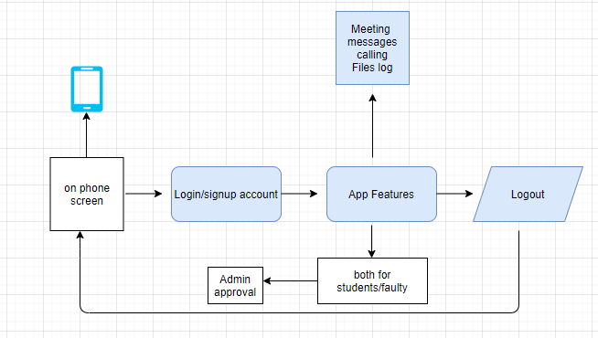

Figure : Architecture diagram

* 1. **Design description**

These are the modules constituting the project to be developed. We are documenting only the salient properties and methods of each module to keep the description simple and more readable.

* + 1. ***Launch application***

To launch this application user need to login with their Student id and password. After that user see the home screen and other features as well such as contact list, news feed and other.

* + 1. ***Home page***

**Description:**

After Launching Application this picture will provide the features of home page.

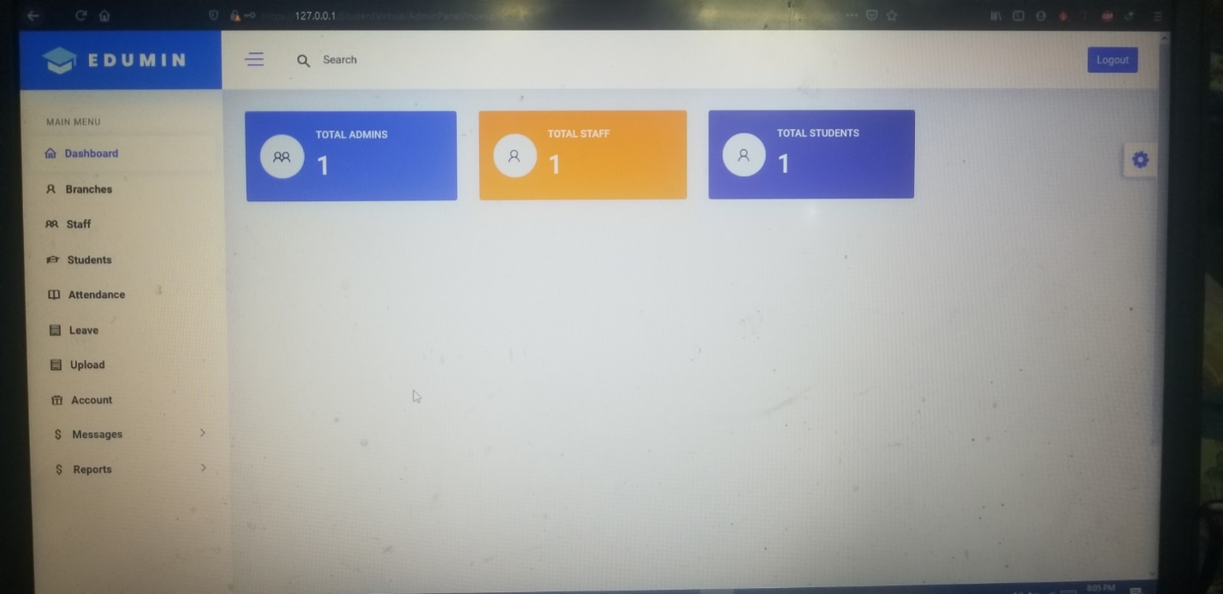

Figure

**Details:** After user launch this application, user need to sign up with their student id and password. Furthermore user sees different features of this application. User see three panel one is for admin and one is for faculty and the other is for students. Students and faculty members can upload a file; the option is given in the side menu bar. User also sees notification in message panel.

* + 1. ***Activity Diagram***

Activity diagrams are graphical portrayals of work processes of step-wise actions and activities with support for decision, emphasis and simultaneous. Activity diagrams demonstrate the general stream of control. Action graphs are developed from a set number of shapes, associated with bolts. The most imperative shape types:

* Filled circle represent start point
* Rounded rectangle represents actions
* Diamond Represent Decision
* An encircled circle represents the end final state

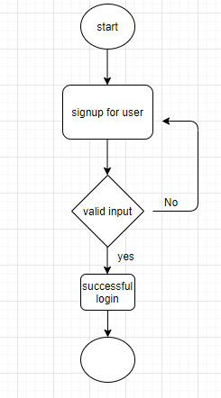

Figure : Home screen

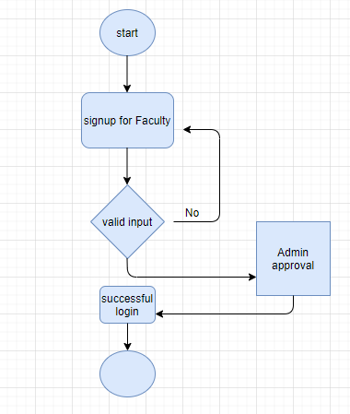

Figure : login for faculty

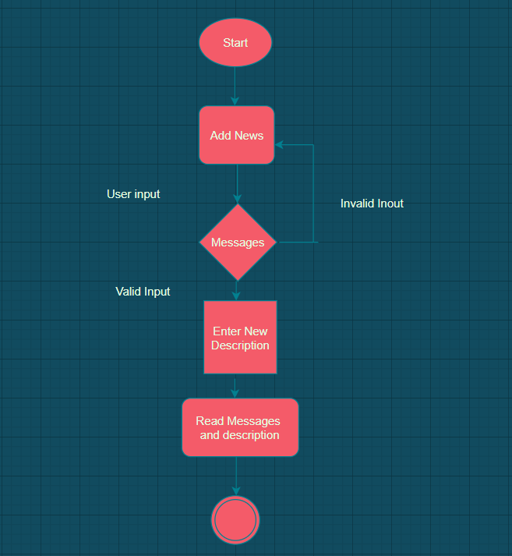

Figure : Discription and message system

* + 1. ***UML use case***

Use case diagram is simplest representation of user interaction with system and the relationship between user and the different cases in which user is involved.

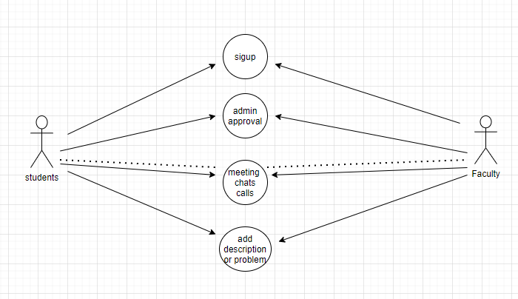

Figure : use case interface